**ME 222**

**NATURE AND PROPERTIES OF MATERIALS**



**Lab Report**

**Experiment No. : 2**

***Stress-Strain behaviour of Elastomers***

Instructor: Dr Bishakh Battacharya

Dr Kamal K Kar

Department of Mechanical Engineering

**Group – A2**

14042 Affan Ahmad

14048 Akash Singh

14052 Akhil Amod

14059 Akshay Bagde

14060 Akshay Bhola

14062 Akshay Sharma

14065 Albart Jose

**Objective of the experiment**

To measure various physical and mechanical properties of an elastomer by

* The Study of Stress-Strain behavior
* To determine the below properties
  + Modulus of resilience
  + Ultimate Tensile Strength
  + Tangent Modulus of Elasticity
  + Secant Modulus of Elasticity
  + Failure Point
  + Yield Strength
  + Modulus of Toughness

**Importance of the experiment**

Designing structures using predetermined materials may result in deformation and failure. Because of that we should understand how the various mechanical properties are measured and what these properties represent. Hence measurement of all the above mechanical properties will help us in building suitable structures with appropriate dimensions for various putposes. These properties ensures that the structure or components satisfy our environmental and physical needs without failures.

**Introduction**

Stress Strain graph helps in calculating various material properties that define the structure of a substance. For building various structures various properties such as **Yield Strength, Tensile Strength, Tangent modulus, Secant modulus, Modulus of Toughness, Modulus of Resilience** etc are very important.

Hence regions in Stress Strain graph such as **elastic region, plastic region, strain hardening, yielding, necking and failure** etc helps in analysing the behaviour of materials under various amounts of loads.

In this experiment we study the effect of loads on an elastomer. Unlike normal materials, elastomers doesn’t behave linearly in the elastic region. And also Young’s modulus, Yield Strength etc are not very important here. Basically after the maximum value called the universal tensile strength it fails or fractures thus giving a simple force vs elongation curve.

**Theory**

Stress is basically the force acting per unit area of a material which is under the application of applied (external) forces. Although the stress generated is defined internally for the cross section of the material.

There are two types of stresses defined:

**Normal stress**- when the forces applied are normal to the cross section of the material then stresses are normal stresses. They can be sub divided to *compressive stresses* or *tensile stresses* depending over the direction in which the force is acting

**Shear stress**-when the forces acting are tangential to the surface then the stress is shear.

Stress can be expressed as



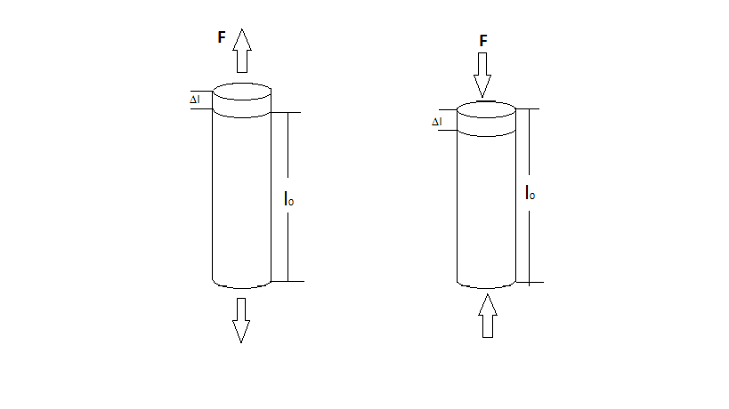

under tension under compression

Strain-on the application of applied external forces the internal stresses develops which results in the deformation (dimensional change) of the material in stress. The relative change in the material dimension is defined as strain

Normal strain is expressed as

(Where L is for length dimension) 

Some terminologies associated with stress-strain are

**TRUE STRESS** -it is the force that acts per unit area(area of application being instantaneous).

$σ_{TRUE} = \frac{f}{a_{inst}}$

**True strain**-it is the ratio of the incremented length to the length at that instant.

$$δϵ_{True} =\frac{δL}{L}$$

$ϵ_{TRUE} = \int_{L(o)}^{L(i)}{\frac{δL}{L}}= log⁡( \frac{L(i)}{L(0)} )$

Stress is related to strain of a ductile material and is depicted by the qualitative graph given below

here, till yield point the graph is linear and the deformation occurs is elastic after yield point the stress increases due to strain hardening and reaches to ultimate stress point after which a uniform decrease in the cross section occurs although there is a sudden increase in true stress due to which necking occurs and finally the material fails as it reaches the fracture point

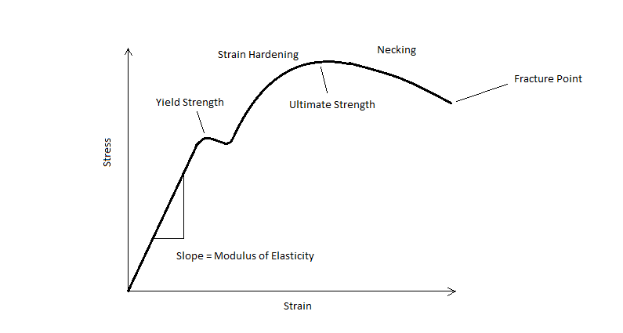

In contrast brittle material behave differently in concern with their stress strain relation

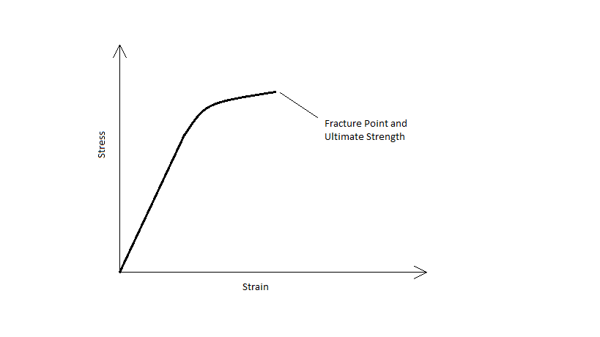

Here, the brittle materials behave linearly upto a certain stress point after which even slight plastic deformation results in failure/fracture of the material. Unlike ductile material they do not have a yield point and the point for ultimate stress and fracture are the same.

**Experimental condition**

The experiment in conducted at normal temperature and pressure on an Instron Universal tensile machine where the machine provides a constant strain rate till the sample fails or fractures. The maximum load that can be applied by the machine in 10kN and is ideal for plotting the Stress Strain relationship for an elastomer. We use 5 black dog bone shaped elastomer strips for the experiment.

**Procedure**

* Length ,Width and Depth of the strips are measured and is tabulated
* The length and strain rate are given to the Instron UTM and the strip is held in between the jaws.
* The sample is brought to zero load position and then tensile load is applied
* Load is applied till the sample fractures and is done in 5 similar elastomers at various strain rate.
* Data noted on computer is used to plot the Stress-Strain curves
* From the curve we find all the required material properties.

**Dimensions of Samples**

|  |  |  |  |  |
| --- | --- | --- | --- | --- |
| *Sample No.* | *Gage length* | *Width* | *Thickness* | *Strain Rate* |
| 1 | 30.00 | 4.07 | 3.20 | 5 |
| 2 | 31.50 | 4.00 | 3.04 | 10 |
| 3 | 30.18 | 3.88 | 3.20 | 15 |
| 4 | 31.68 | 3.94 | 3.28 | 20 |
| 5 | 29.48 | 3.68 | 2.72 | 25 |

gage length, width, and thickness are in mm and strain rate in mm/min

**Diagrams**

**Standard Force Vs Elongation curve for various strain rates on elastomers**

1. *Strain rate = 5mm/min*

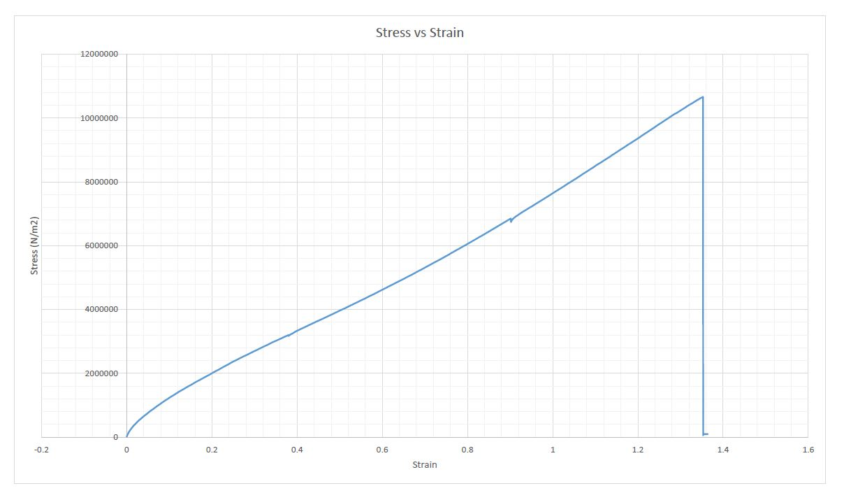

1. *Strain rate = 10mm/min*

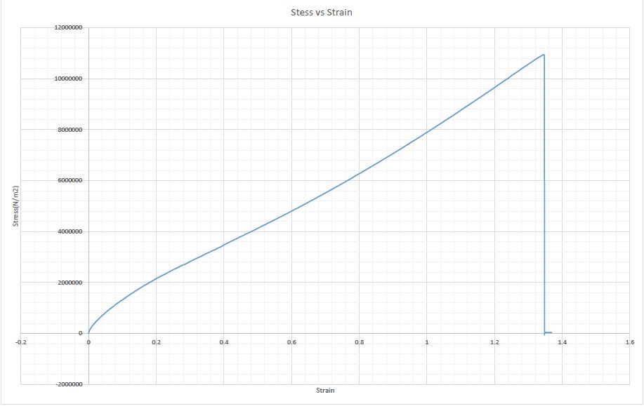

1. *Strain rate = 15mm/min*

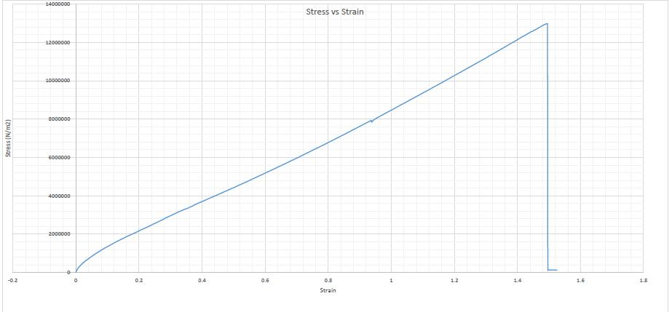

1. *Strain rate = 20mm/min*

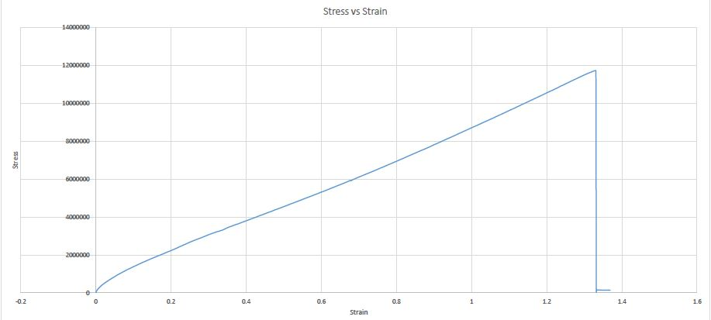

1. *Strain rate = 25mm/min*

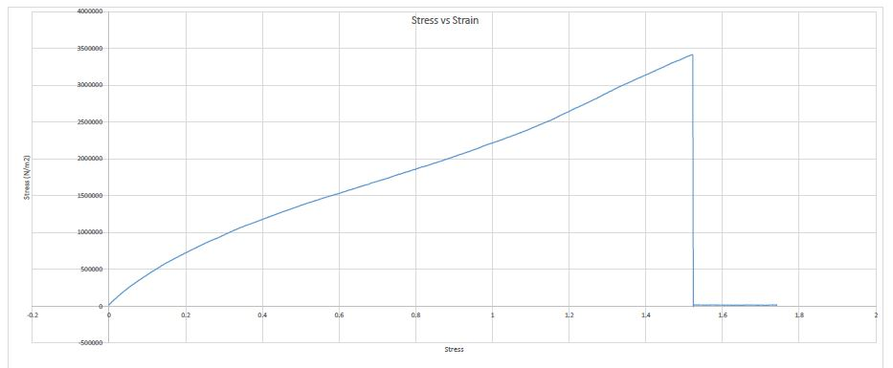

**Result**

|  |  |  |  |  |
| --- | --- | --- | --- | --- |
| *Sample no.* | *Strain rate* | *Universal tensile force* | *percentage reduction in area* | *Universal tensile force(*10^6 pa)* |
| 1 | 5 | 138.826 | 57.49 | 10.66 |
| 2 | 10 | 133.183 | 57.39 | 10.95 |
| 3 | 15 | 161.276 | 59.91 | 12.99 |
| 4 | 20 | 155.457 | 57.08 | 12.03 |
| 5 | 25 | 34.1703 | 60.35 | 3.41 |

**Discussion**

Universal Tensile Strength should have increased with increase in strain rate but due to difference in elastomeric materials and error in calculation of physical dimensions resulted in distorted values. Errors might happen in measuring gage length, width, thickness and also due to imperfection in the solid substance properties may vary hence the last sample gave very low tensile strength. Also the fracture may not happen in centre due to unevenness in substance making us difficult to predict the fracture point and value. But from the above result we can see that the fracture happened when the percentage reduction in area is between 55% to 60%. Also percentage reduction in area or greatest elongation at rupture increases with increase in strain rate is almost accordance with the experimental value.

**Conclusion**

From this experiment we can see that unlike normal materials Stress is directly proportional to strain throughout its time till it fractures at certain point where we get the universal tensile strength. For our sample we can observe the tangent and secant modulus are almost equal. Also the curve is slightly curved upwards in most of its region.

**Precaution**

* We should ensure that initial load must be made zero before starting the experiment
* Machine parts should be handled carefully because the are costly and sensitive.
* Dimensions should be measured accurately and entered in machine program.

**Reference**

* Materials Science and Engineering, An Introduction by William D. Callister.
* Lab manual , ME 222A, Prof. Kamal K. Kar.
* Wikipedia.